Last Name: ____________ First Name: ____________ Date: _______ Class: BIO3 Section: ________ 1
Assignment 4 - Cellular Respiration & Fermentation
- Explain the difference between a calorie (c) and a kilocalorie (C). kilocalorie is the amount of heat required to raise temperature of 1 kilogram of water while calorie is the energy inform of heat
- Nutrition facts listed on various foods indicate the amount of calories per serving. Are the calories on these labels indicating calories or kilories? Calories
- What body system is responsible for physical and chemical digestion of food in humans? Digestive system
- What body system distributes absorbed nutrients throughout the body, so that the cells comprising the tissues may receive these nutrients blood circulatory system which is cardiovascular system
- Draw a diagram of a mitochondrion. Label ALL of the following: outer membrane, inner membrane, intermembrane space, matrix

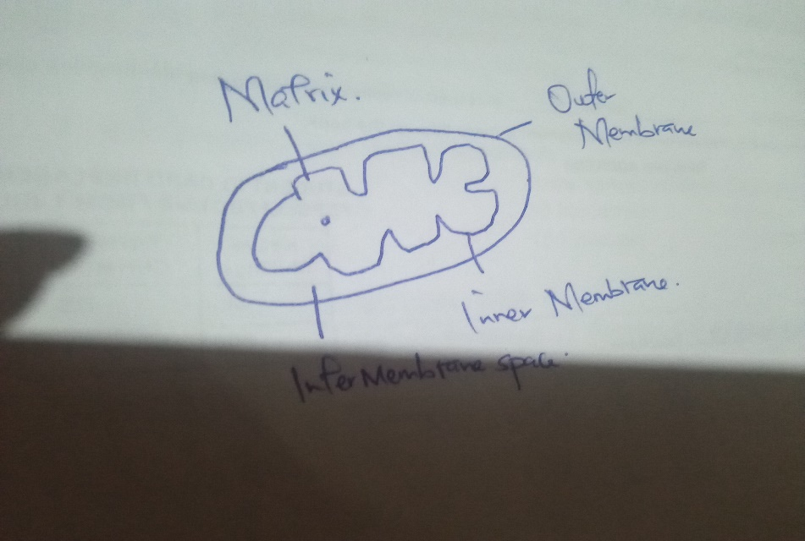

- Define cellular respiration:
set of metabolic reactions and processes that take place in the cells of organism to convert chemical energy from oxygen molecules to nutrients

- Complete the following overall chemical equation for cellular respiration by writing in the chemical formula where underlined and the name of the molecule within the parentheses.
C6H12O6 ( sugar ) + 6 O2 ( oxygen ) ! 6 CO2 (carbon dioxide) + 6 H₂O (water)

8. List the 5 steps in cellular respiration:
1. Glycolysis
2. Preparatory step
3. Link reaction
4. Krebs cycle
5. Oxidative phosphorylation
9. For glycolysis, complete the following table

Glycolysis
Is oxygen required for this process? | Oxygen is not required its anaerobic respiration
Where does it occur? | cytoplasm
What reactant is required? | Glucose and oxygen
How much of each of the following products are produced? | ATP - 38  NADH -2  Pyruvat- 1

10. Prior to entering the mitochondrion, pyruvate must be converted in acetyl. This is called the oxidation step and occurs in the eukaryotes.
11. For the preparatory step, complete the following table:
Preparatory step
Is oxygen required for this process? | Oxygen is not required
Where does it occur? | eukaryotes
What reactant is required? | Carbon dioxide
How much of each of the following products are produced? | CO2 _________ 1  NADH _________ 2  Acetyl CoA………… 2

12. For the citric acid cycle, complete the following table:
Is oxygen required for this process? | It required indirectly at the end of the chain by electron transport chain.
Where does it occur? | In the matrix of mitochondria
What reactant is required at the beginning of the citric acid cycle? | Acetyl-CoA
How much of each of the following products are produced? | CO2 2 molecules  NADH 1 molecule  FADH 1 molecule  ATP 1 molecule

13. What is the fate of the carbon dioxide made in the prepatory step and citric acid cycle?
1. Plants carbon dioxide molecules are released in reaction to produce NADH
2. Animals carbon dioxide is also given out.
14. What is the fate of NADH and FADH from the citric acid cycle?
They are broken down to macromolecules which can be broken down into intermediate products.

15. For the electron transport chain, complete the following table:

Is oxygen required for this process? | Its important acceptor which allows for oxidative phosphorylation.
Where does it occur? | Inner mitochondrion membrane
What reactant is required at the beginning of the electron transport chain? | 2 hydrogen ions and 2 electrons
Where are hydrogen ions pumped? | To the matrix

16. What is the function of the ATP synthase? Synthesis ATP from ADP and inorganic phosphate
17. Explain what fuels the ATP synthase when making ATP from ADP and Pi.
Phosphoanhydride bonds have the energy that catalyzes ATP synthase enzyme which is found in the inner membrane of mitochondria
18. In which part of cellular respiration is the majority of ATP produced?
Electron transport chain
19. Why do animals require a respiratory system
To bring in oxygen and remove carbon dioxide to survive
20. What is the goal of fermentation?
Convert NADH chemical compound to co-enzyme NAD so that it can be used again.

21. List 3 types of fermentation.
1. Acetic acid fermentation
2. Ethanol fermentation
3. Lactic acid fermentation
22. What is the reactant for fermentation? NADH and a proton
23. Explain why fermentation useful to bacteria and yeasts?
In yeast they have the role in production of beverages due to ability to accumulate more ethanol that can produce different aroma in foods. Bacteria produce various flavor compounds.
24. Explain why fermentation useful to animals, including humans?
This increases the health of your gut microbiome and digestive system and enhance immunity system.

